Pokhara University

Level: Bachelor | Semester – Spring | Year : 2009
Programme: BE |  | Full Marks: 100
 |  | Pass Marks : 45
Course: Network Theory |  | Time : 3hrs.

Candidates are required to give their answers in their own words as far as practicable.
The figures in the margin indicate full marks.

Attempt all the questions.

 | - In the given circuit, switch opens at t=0.  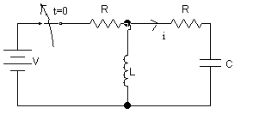  - Find differential equation of i(t) for t>0.  - Find i(0⁺) and di/dt(0⁺)  - Solve i(t) for V=12 V,R=4Ω,c=1/3F and L=1 H.  - Find the total response v_{c}(t) for the voltage across the capacitor in circuit given below using classical method. The switch S is closed at t=0.  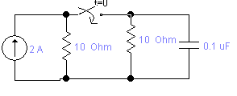 | 8  7
 | - A dc current of 5A is suddenly connected to a parallel RLC network at t=0. Obtain the particular solution for voltage v(t) across the circuit elements. Given that R=1/5Ω, L=0.1H and C=4F. Assume zero initial charge across capacitor and zero initial current through inductor.  - An R-L circuit is connected to an ac voltage e=100sin (500t+30) volts at t =0.If R= 5 Ω and L=0.01 H,find the equation for the current using classical method. | 8  7
 | - What are the advantages of laplace transform over classical method? The response v(t) in a series RLC circuit is described by the differential equation  d²v/dt²+12 dv/dt+100v=1000  the initial conditions are v(0)=0 and dv/dt(0)=0.Find the complete  response for v(t) using Laplace Transform method.  - Solve the following equations using the Laplace transformation method: [7] [Laplace Transform]  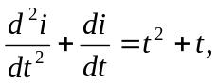Given that 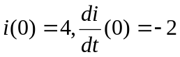 | 8  7
 | - Check for the positive realness of given function [7] [One Port Network]  Z(s) = (2s²+2s+4)/(s³+2s²+s+2)  - The denominator polynomial of a network is given as  S⁴+S³+S²+S+K=0  Determine the range of K for which the system is stable using  Routh- Hurwitz criteria. | 8  7
 | - Sketch the straight line asymptotic magnitude response for the following transfer function.  G(s) = 10s / (1+0.5s)(1+0.1s)(1+0.12s+0.04s²)  - Obtain the Fourier series representation of the waveform shown.  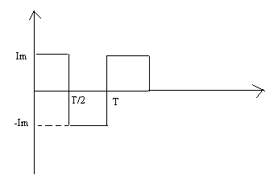 | 8  7
 | - Find z and y parameters of the given circuit.  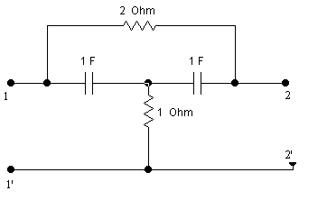  - Synthesize the given LC network function in Foster and Cauer  first forms. [7]  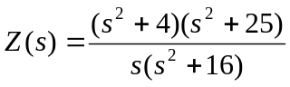 | 8  7
 | Write Short notes on (Any Two):  - Hybrid Parameter representation of two port network  - Symmetry and Reciprocity of the network  - Different types of Filters | 5×2

